Enabling Technology for Reactions and Processes

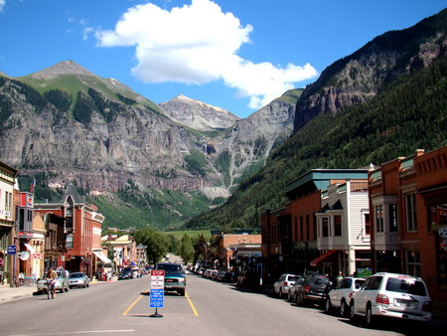

Tentative Schedule:

 | Sunday | Monday | Tuesday | Wednesday | Thursday | Friday
8-8:30 am |  | Breakfast | Breakfast | Breakfast | Breakfast | Breakfast
8:30 am |  | Jason H | Greg D | Rebecca R | Karl S | Planning meeting
10 am |  | Break | Break | Break | Break
10:30 am |  | Annaliese F | Tianning D | Glenn M | Jared S
noon |  | Lunch | Lunch | Lunch | Lunch
1:30 pm |  | Jon T | Adrian B | Jake J | Amanda E
3:00 pm |  | Break | Break | Break | Break
3:30 pm |  | Paul C
6 pm | Badge pickup¹  (6-8pm) |  | Town Talk² | TSRC Picnic³  (6–9pm)

¹ Badges will be available for pickup on Sunday night from 6 pm - 8 pm at Arroyo Bar or on Monday morning starting at 7:30 am. https://www.telluride.com/arroyo-gallery-wine-bar

² The Town Talk will be held at the Telluride Conference Center in Mountain Village.
The speaker and topic are to be determined.

³ The TSRC Picnic will be held on Wednesday evening at the Telluride Elementary School. Friends and family are welcome free of charge.

Participant list:
Jason Hein (UBC) jhein@chem.ubc.ca
Greg Dudley (WVU, starting July 9) gdudley@chem.fsu.edu
Jon Tunge (Kansas) tunge@ku.edu
Annaliese Franz (UC Davis) akfranz@ucdavis.edu
Karl Scheidt (Northwestern) scheidt@northwestern.edu
Paul Cheong (Oregon State) paul.cheong@oregonstate.edu
Adrian Burke (Mettler Toledo) adrian.burke@mt.com
Jake Janey (BMS) jacob.janey@bms.com
Tianning Diao (NYU) diao@nyu.edu
Glenn Micalizio (Dartmouth) glenn.c.micalizio@dartmouth.edu
Jared Shaw (UC Davis) jtshaw@ucdavis.edu
Rebecca Ruck (Merck) rebecca_ruck@merck.com
Amanda Evans (Cal St Fullerton) amevans@exchange.fullerton.edu

